FRC Alliance Selection Script 2025 v3-5bh

** The MC runs the Alliance Selection on the playing field. The Alliance Selection is an important part of the event for both teams and audience, and should be presented with as much energy, enthusiasm, and professionalism as the rest of the event. Emcees must exactly follow the timing and wording outlined below to meet required ceremony timing. There are many changes with the new process, please review this process prior to beginning the Alliance Selection.
The playing field should be preset with the 8 Captain armbands arranged in two rows of four: four armbands across the front of the field, and four across the back. A Field Assistant will help direct teams on the field.

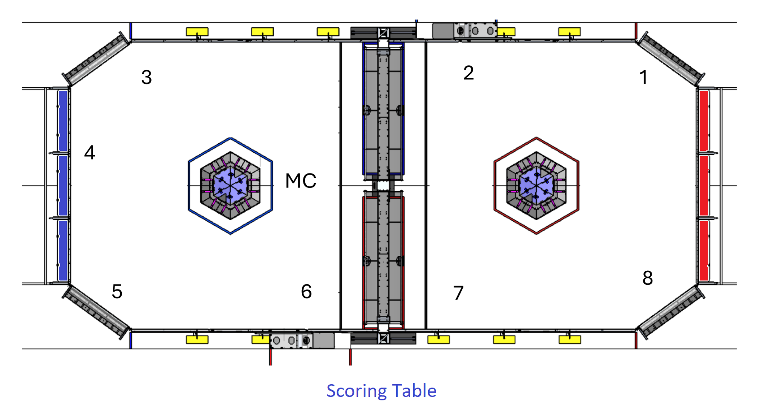

PRE-ALLIANCE SELECTION
At the end of Qual. Matches when the 8:00 Timer starts (this text is also in the Event script):

EMCEE We’ve had a great competition so far with plenty of exciting Qualification Matches, let’s hear it for all the teams competing!
Soon we move on to the Playoff Tournament, where eight Alliances of three teams each will compete against each other in a double elimination format to become the Champion here in _________________.
But before we begin the Playoffs, we need to create the eight Alliances. Here’s a video which helps explain the new selection process and remind you of the afternoon’s Playoff and Awards Schedule. We’ll be back in a few minutes – when the timer hits zero – to begin the Alliance Selection! Let’s roll it!

roll Selection Process-Playoff Schedule video (trt 6:58)
----- SELECTION ROUND 1-----

EMCEE
Welcome to the Alliance Selection ceremony! We’ve reviewed the Selection rules so now it’s time to create some alliances.
Let’s meet the number 1 ranked team, with a record of ___ wins and ___ losses please welcome Team # ______________
(After the pick, the Field Assistant will place the Team Reps on the field by the appropriate Alliance Capt. arm band, which have been preset. The Number 1 Seed should be positioned near the Red Alliance Driver Station #3 – see diagram. When a pick is made, the MC should repeat the Team number, then the Game Announcer should announce the Team nickname and hometown as the Team Reps walk onto the field.)

EMCEE
Alliance 1, when you’re ready, one student only must approach me to announce the selection. Your 45 seconds begins now, you are on the clock.

EMCEE NOTE: Always use the phrase “You are on the clock” as the final thing you say. It is the cue for the FTA to start the Timer.

(the pick timer begins to run)

- If a CAPTAIN SELECTS A TEAM WHICH IS IN A CAPTAIN POSITION, say: “Would you prefer to join or form your own Alliance?”

- If the pick ACCEPTS:
  - Say “Congratulations” and repeat this process with Timer if there are remaining captains to introduce.

- If the pick DECLINES:
  - Say “Alright, let’s reset that pick timer for you. Let me know when you are ready to invite another team, you are on the clock.”

- If NOT A VALID PICK:
  - Say “Unfortunately, that team is not a valid pick and you have X seconds left to make a valid selection. You’re welcome to go back to confer with your team, if you’d like. The timer has resumed, you are on the clock.”

- If they DO NOT MAKE A PICK:

- Say “It looks like time has expired.”
  - If this is the last pick in this round:
    - Say “As this is the last pick in this round, this will be an automatic selection. Please welcome the next highest seeded Team #________ to Alliance #_______”

  - If this is not the last pick in the round:
    - Say “We’re going to skip this Alliance for now, and they’ll have a chance to pick after the next Alliance selects a team.”

AFTER bringing out the Alliance 8 Captain and BEFORE starting the timer,
and ONLY IF there are NO outstanding picks, say:
Alright, and with that, Alliance 8, when you’re ready, one student only must approach me to announce your selection. Your 45 seconds begins now, you are on the clock.

If outstanding picks, wait for their pick and follow the same process as above upon Accept or Decline or Automatic Pick.

That concludes our first Selection Round. Before we begin round two, the Alliances have 2 minutes to confer. We’ll begin Round 2 in just two minutes.

(play music, keep the Alliance chart on the Audience Display)

----- SELECTION ROUND 2 -----

EMCEE
We’re about to see the strategies of these Alliances play out as they look to partner with teams whose robot complements their own to create the strongest possible alliance. The eight Alliances will compete in the double elimination Playoff Tournament, leading to a best two out of three set of Finals matches.

During the second round of selections all teams have a 90 second limit to make their pick. Alliance 8, when you’re ready, one student only must approach me to announce the selection. Your 90 seconds begins now, you are on the clock.

*USE THE SAME PICK LANGUAGE AS USED IN THE 1st SELECTION ROUND* - always using the phrase “You are on the clock” as the final thing you say

BEFORE THE FINAL PICK:

EMCEE
There is one spot left in the Tournament. After our Number 1 Seed makes their final selection, it is still possible that the next eight highest ranking unselected teams could compete. If a robot becomes non-functional during the tournament, each Alliance has one opportunity to substitute in a robot from the backup pool. The backup teams will come in by ranking order, starting with the highest ranked remaining team.

We’ll need the student representatives from the backup teams to confirm their participation in the Playoffs with the Lead Queuer in just a moment.
(The Lead Queuer should be standing off the field with the line of Team Reps.)

But now it’s time to find out who Alliance number 1 would like as a member of their Alliance. Alliance 1, your 90 seconds begins now, you are on the clock.

After all eight complete Alliances have been created:

EMCEE
Well done, this looks to be an exciting tournament! Let’s have a round of applause for all the teams competing here in _________________. Teams gave it their all here this weekend. If you weren’t selected for the Playoffs, pick an Alliance to cheer on!

Now we need all Alliance Captains to stay here on the field to meet with the Head Referee to review Playoff rules. It is now allowed to swap out the Alliance Captain if needed.
We’re going to let the Alliances strategize and prepare for the Playoff Tournament which will be starting at _______pm.
We will be presenting many awards between the Playoff Rounds and will have the Closing Awards Ceremony immediately following the Playoff Tournament.We’ll see you back here to begin the Playoffs – and don’t forget to bring your Gracious Professionalism - thanks everyone!

(play lunch break music and video rolls)

